Ways You Can Help the Damien Center
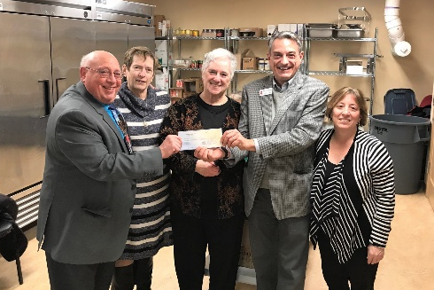
DONATE
One of the most impactful ways to help is to donate to support those in need in our local community. We have more individuals and families in need now than at any other point in the AIDS epidemic. Your generous gifts can support and expand our impact by:
- Visiting albanydamiencenter.org/donate
- Mailing a check or money order to "Albany Damien Center" at 728 Madison Avenue, Suite 100, Albany, NY 12208.
- Calling 518-449-7119 x121 to make a donation over the phone.

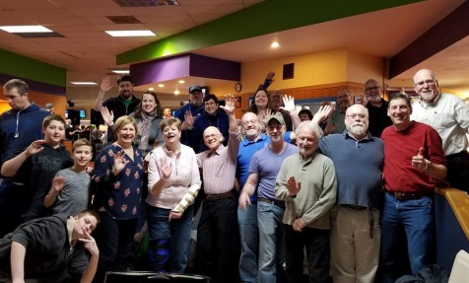
ORGANIZE A GROUP AND ATTEND AN EVENT
We have several events throughout the year to raise awareness, inform the community about our programs, and raise money to support our mission. We are hoping in 2022 to have in-person events including:
- Bowling for PAWS – at The Spare Time in Latham to benefit our PAWS Program
- Hero Awards – held annually to recognize an individual in our region who has done extraordinary things to help in our community.
Join our email list to get the latest updates and invitations!

DONATION DRIVES
We value every in-kind donation we receive whether it is made directly to the Damien Center! We’re always in need of the following items:
- Food: canned veggies and beans, grains, pasta, spices, & other healthy foods
- Pet food and supplies: dog and cat food, treats, kitty litter, & other pet supplies
- Personal care items: soap, razors, body wash, shaving cream, deodorant, & feminine products, et al.
All items can be dropped off at our front desk anytime as we are open 24/7.

HOST A FUN-RAISER!
Do you have energy, time, and passion? Then consider throwing a fundraiser for us! This is a great project for your organization to help raise needed funds and awareness of HIV/AIDS! You can even throw one online for your birthday or a special occasion.
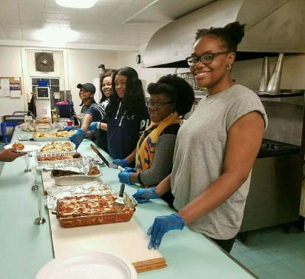
- Host a party or event at your place of worship
- Organize an event at a restaurant, bar, park or another venue
- Create your own fundraising page and encourage online donations
We have systems and resources to support your fundraising!

VOLUNTEER
We love volunteers! Volunteers are extremely important in helping the Damien Center operate each day. There are multiple volunteer opportunities and flexible schedules available in our Kitchen, PAWS, Living Room, Front Desk, as well as group activities!

