November 30, 2021

Dear Friends:
Our most vulnerable members of our local community continue to struggle with equal access to medical care, medications, housing, food, and many other critical supports needed to survive AIDS and prevent new HIV infections. With COVID and the coming winter, barriers to health are increasingly experienced by people coming to the Damien Center for the first time, in-person, since the COVID pandemic unhinged all our lives.
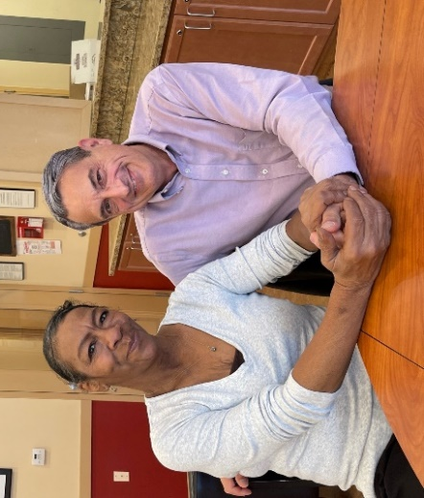
In July of 2021, after a year and a half of providing care remotely, by pickup, and through delivery, we re-opened our doors so all our members could safely reconnect with the magic of the Damien Center. Seeing our members in person, after so much time, was truly emotional for me. I imagine many of you felt the same way when you first got to see your loved ones in person again.
My most vivid memory was seeing Linda, who had returned to work in the kitchen with our Smart Meals Team. Seeing Linda brought me to tears – and they were indeed tears of joy.
Linda, a long-time member of the Damien Center, was diagnosed with HIV at the age of 27. She found out on her birthday. For Linda “the hurting part” was how quickly HIV became a barrier to living the life she had imagined. In addition to HIV, Linda overcame cancer and several strokes.
At the Damien Center, Linda found a community to belong to and a source of support in her numerous journeys back to good health.
When COVID struck Linda felt herself thrown back into isolation and despair. She knew where to turn. In July, Linda came back helping to prepare meals for our Damien Center members.
Your help ensures that the Damien Center can provide life-saving services. These services include nutritious meals, housing, mental health counseling, PAWS, employment and educational support, pharmacy services, and much more. With your help we have sustained (and grown) a loving, community center environment since our founding in 1988.
Linda is one of the hundreds of individuals and families whose lives have been changed for the better at the Damien Center. We fill life with hope, love, and connection to a community that is truly caring. With your help, we can continue to make a difference, one person at a time.
Please give–whatever you can– to help people like Linda realize their goals and dreams.
Sincerely,
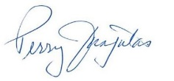

Perry Junjulas, Executive Director & Person with AIDS who is UNDETECTABLE

Name(s): _____________________________________________________________________________________________
Address: ______________________________________________________________________________________________
Phone: ________________________________ Email: __________________________________________________________
Please accept my gift of: $25 $50 $100 $500 $1,000 other $_______________ (specify)
Kindly make your check payable to “The Albany Damien Center”;
Or charge my card: One-Time Monthly Quarterly Semi- Annually Annually:
Card #:__________________________________________________CV_______________ Exp. Date ________/________
Name on card __________________________________________ Signature: ___________________________________
This gift is in Honor of In Loving Memory of: __________________________________________________________
Please mail acknowledgment of this gift to: ______________________________________________________________
Please mail to: Albany Damien Center, 728 Madison Ave, Ste 100, Albany, NY 12208 OR Give online at albanydamiencenter.org/donate

