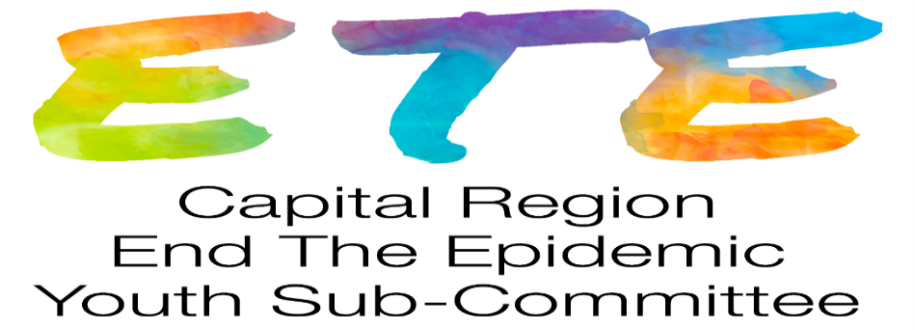
Meeting Summary Thursday 11/19/2020 4pm via Zoom
Participants: Alliance for Positive Health Real Talk: staff Hannah, Brian, Krystal; five youth; Specialized Care Center Albany Med: Mary Ellen, Lauren; Damien Center: Lyndsi; HIV Stops with Me: Mars
1. Welcome, introductions
2. Old Business
- Link to videos developed by youth for AMC SCC dinner programs on HIV/STD
https://www.youtube.com/watch?v=zruPircBY9U
https://youtu.be/Ku6rzQWAWJk
https://youtu.be/3DgtKv2BrBA- PrEP Panel discussion- Real Talk Youth SCC Providers
-The website, www.dos.ny.gov/info/register.htm, provides information on regulations
that open for public comment and you can register to get notifications

3. World AIDS Day- December 1-3 All virtual event this year. Real Talk & Specialized Care Center will promote on their Facebook pages.
Mars has done a short segment with 7-8 other spokesmodels from the HIV Stops with Me campaign that will be shown at World AIDS Day.
Link to register- https://whova.com/web/endin_202012/ everyone/anyone is welcome to attend.

4. Agency Updates- Mars- HIV Stops with Me- Youth Empowerment Fundraiser- All proceeds going to the Damien Center. 25-day long fundraiser, anyone can donate directly to the fundraiser or Mars is also looking for youth that are crafty/artsy to donate their work to be sold and the proceeds with go towards the fundraiser. Fundraiser ends 12/12. Toiletry items can also be donated. There is a drop off date from 1pm-4pm on 12/12 for these items.

Real Talk/Alliance for Positive Health- Testing on Thursday’s by appointment only. Real Talk is winding down, unfortunately the Real Talk program hasn’t received funding to continue running. This program will end as of 12/30/2020. Until then, they are still running 2 virtual groups and doing food/condom drop off. Testing Alliance does: 3 site Gonorrhea & Chlamydia testing, Rapid Hep C & Syphilis, Rapid 3rd Generation HIV Testing.

Damien Center- Most services are being done remotely. Still doing enrollment for programs. MPower- is doing STI & HIV testing by appointment. Employment Services is still enrolling participants, it is being done remotely. Employment Program is doing a Facebook live on “Anything Employment” every Wednesday from 2pm-3pm.
MPower contact- Ryan Ramdass- RRamdass@albanydamiencenter.org 518-694-2099
Employment Services contact- Lyndsi Holmes-Wickert Lholmes@albanydamiencenter.org 518-449-7119 Ext. 120

Specialized Care Center- Call ahead rapid HIV testing on 12/1. Call ahead STI/HIV testing is still available for same day/next day appointments. Website for program has been updated and there is a video about our program and services we provide. www.amc.edu/SpecializedCareCenter Phone #- 518-262-9789

5. HUGE SHOUTOUT TO REAL TALK STAFF AND YOUTH FOR ALL OF THEIR INVOLVMENT WITH THIS COMMITTEE. YOUR FEEDBACK AND ASSISTANCE WITH EVERYTHING HAS BEEN GREATLY APPRECIATED!!!!!!

6. Future meetings:
Youth ETE virtual Thursday January 28 4p
Capital Region ETE Steering Committee meeting: every month on 3rd Tuesday 9a, (except August and
December) next 1/19/20

