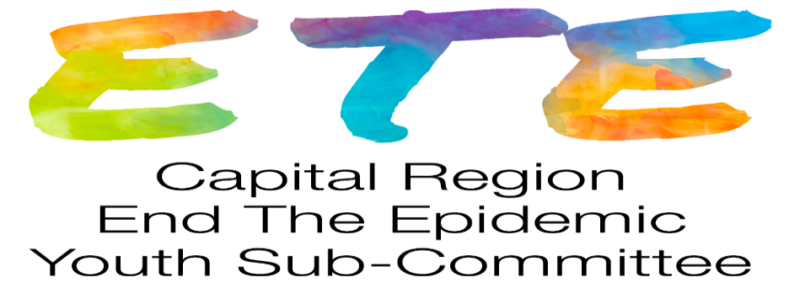
Thursday January 28, 2021 3:30p
Meeting via Webex
Participants: AMC Adolescent/Young Adult program: Kate, Brooke, Bernadette, Lauren; Alliance for Positive Health Real Talk: Stephen, Charlton School: Susan, 1 youth; Damien Center Lyndsi

1. Welcome, introductions
2. Old Business
- Link to videos developed by youth for AMC SCC dinner programs on HIV/STD
https://www.youtube.com/watch?v=zruPircBY9U
https://youtu.be/Ku6rzQWAWJk
-The website, www.dos.ny.gov/info/register.htm, provides information on regulations
that open for public comment and you can register to get notifications

3. Youth Discussion- what would you like to see out of the committee?
Feedback given from youth/youth agency providers:
- Youth felt connected to the committee and were excited to attend meetings
- Like the mission of the committee
- Like being listened to and advocate for others
- Enjoy working on projects with an outcome, projects they can see and show people
- Want to participate in hands-on projects
- Do ice breakers during meeting so those that attend can get to know each other better.
- Tie in substance use and harm reduction and how it relates to HIV
- Simple task/projects

4. Agency updates on Youth outreach and services
Real Talk- Free Rapid HIV testing is still available by appointment only. 518-434-4686. Call to discuss other testing options. Thank you all so much to the Real Talk Staff and Youth that have given their time over the past few years to help with this committee! We will miss you all! Best of luck in the future.
Charlton School- Art Center @ Charlton was recently renovated, an Ice-Skating Rink is being installed for Youth to play outdoors and skate. Not doing many off campus outings currently, unless for work or an outdoor activity. Sue is going to discuss with administration if Youth can go off campus to be STI/HIV tested if needed.

Damien Center- MPower is doing testing by appointment only. Call 518-694-2099 to schedule an appointment. Mostly all programming is running remotely, Employment program is still up and running.

Specialized Care Center- Facebook is up and running. Feel free to go on and Like our page (Albany Med Specialized Care Center)! We are doing free rapid HIV testing by appointment. We are opened and safe for STI/HIV testing by appointment as well.

5. Future meetings:
Youth ETE virtual meeting Thursday February 25 3:30pm
Capital Region ETE Steering Committee meeting: every month on 3rd Tuesday 9a, (except August and
December) 2/16/2021

